
DHOLE PATIL COLLEGE OF ENGINEERING
Engineering Graphics
Assignment on Isometric Projection

Q.No | Question | CO | BT  Level
1 | 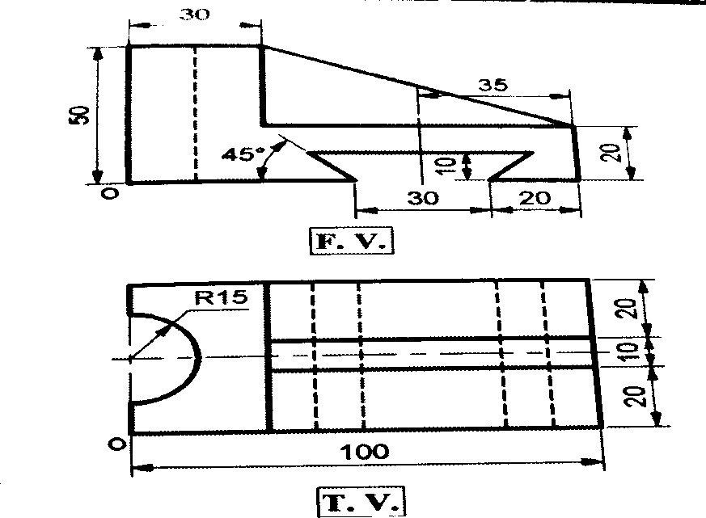 | CO5 | Level 3  Apply
2 | 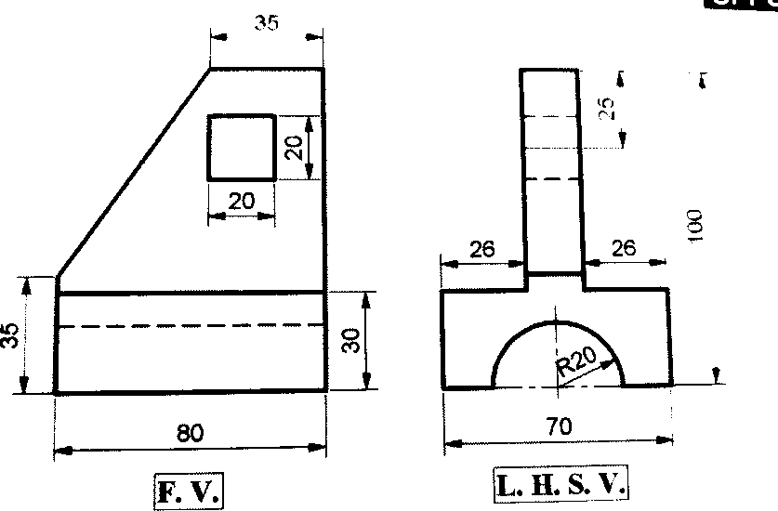 | CO5 | Level 3  Apply

3 | 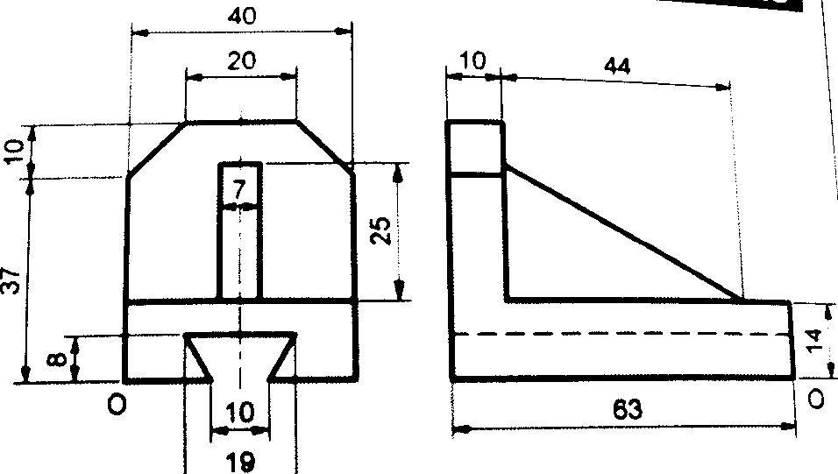 | CO5 | Level 3  Apply
4 | 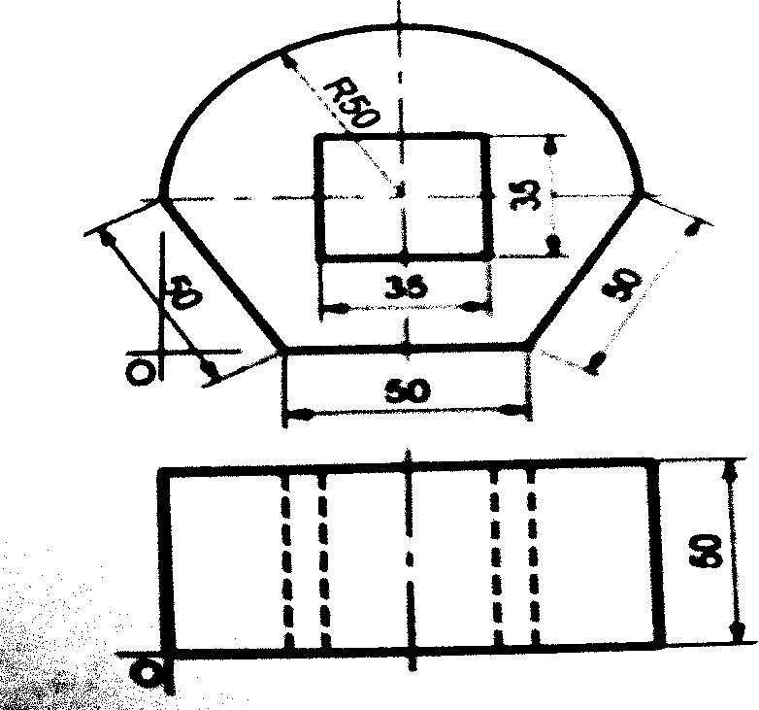 | CO5 | Level 3  Apply
5 | 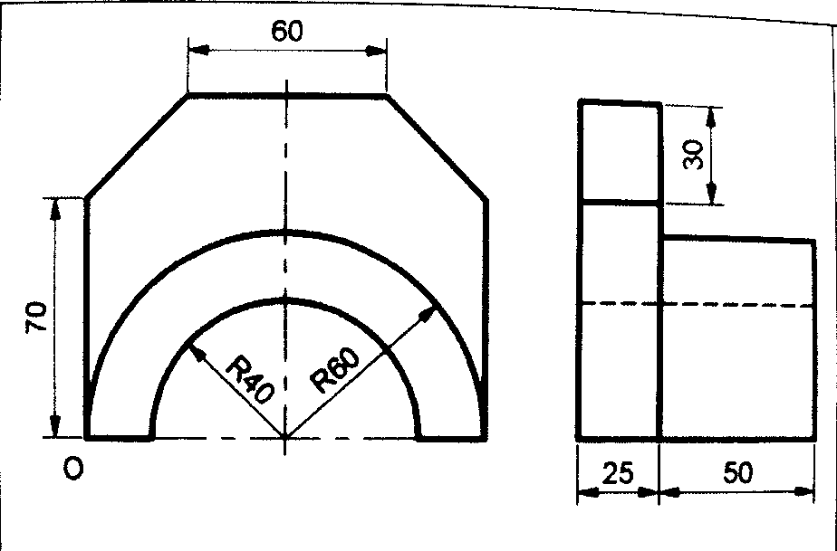 | CO5 | Level 3  Apply

6 | 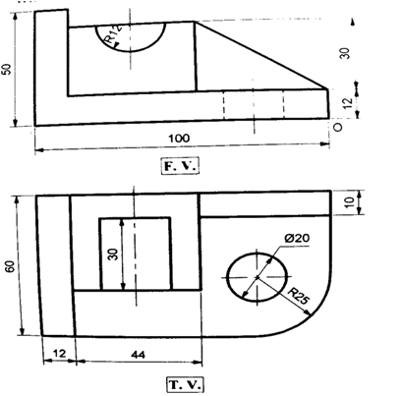 | CO5 | Level 3  Apply

